A Comparison of Team Values in Professional Team Sports

The following charts, tables and report are intended to provide some insight into the changes in team values among the four major United States based professional sports leagues (Major League Baseball (MLB), the National Basketball Association (NBA), the National Football League (NFL), and the National Hockey League (NHL)), over the last ten years. The report begins with overall comparisons among the leagues, and then includes information related to each league. All information was obtained from Financial Times Magazine (1995-97), Forbes Magazine (1997-05), and past issues of Sports Facility Reports (all numbers are in millions of dollars unless otherwise noted).

Comparing the Leagues
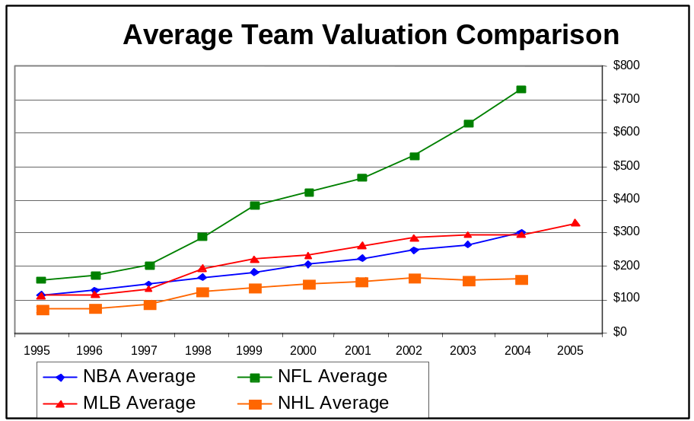

As is clear from the chart above, no league's average team value rose at a rate comparable to the NFL. Over the ten-year span the NFL's average team value went from $160 million in 1995, to $423 million in 2000, an increase of 264%, and then to $733 million in 2004, an increase of another 173%. Overall the NFL's average team value rose by $573 million. The other 3 leagues saw some growth but nothing was comparable to the NFL: MLB's average value increased by $221 million; the NBA's average value increased by $188 million; and the NHL's average value increased by $92 million.

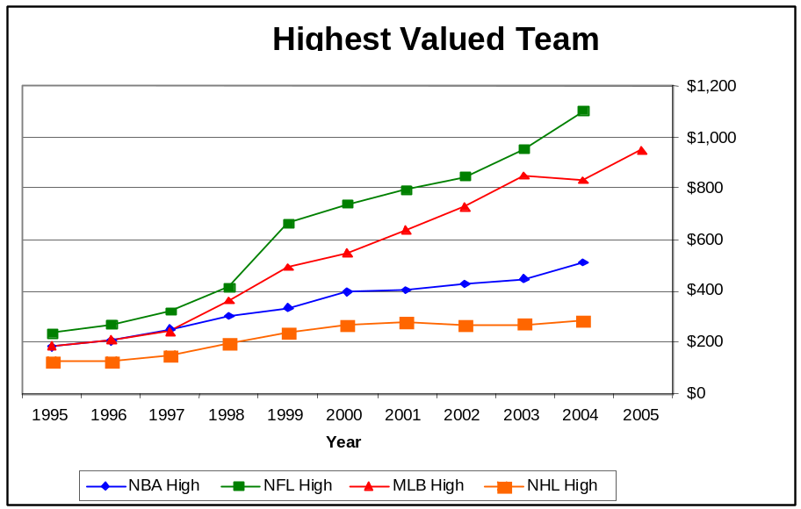

With the exception of MLB, which has kept pace with the NFL, the same disparity in team values is evident when looking at the highest valued teams. In 1995, the team with the highest value in professional sports was the NFL's Dallas Cowboys at $238 million. MLB's New York Yankees ($185) and the NBA's Detroit Pistons ($180) were both about $60 million less valuable at that time. At the same time, the NHL's Detroit Redwings franchise was worth only half of the value of the Cowboys at $124 million.

This disparity continued in 2000, when the NFL's highest valued team was the Washington Redskins, at $741 million. At this point the only league keeping pace with the NFL was MLB. The New York Yankees franchise was valued at $635 million, still a difference of more than $100 million. At the same time the highest valued team in the NBA was still $346 million less than the Redskins, or about half as valuable (the New York Knicks at $395 million), while the highest valued team in the NHL was $478 million less, or about two thirds less valuable (the New York Rangers at $263 million).

By 2004, the Redskins had again increased in value to $1.1 billion, while the New York Yankees had increased to $832 million, now a $272 million difference. However, the other leagues have not kept pace. While in 1995, the NBA team with the highest value was within $52 million of the value of the NFL's highest team, by 2004, the disparity had grown to $594 million. This disparity is even greater in the NHL. In 1995 the disparity was $114 million, and by 2004 it was $822 million.
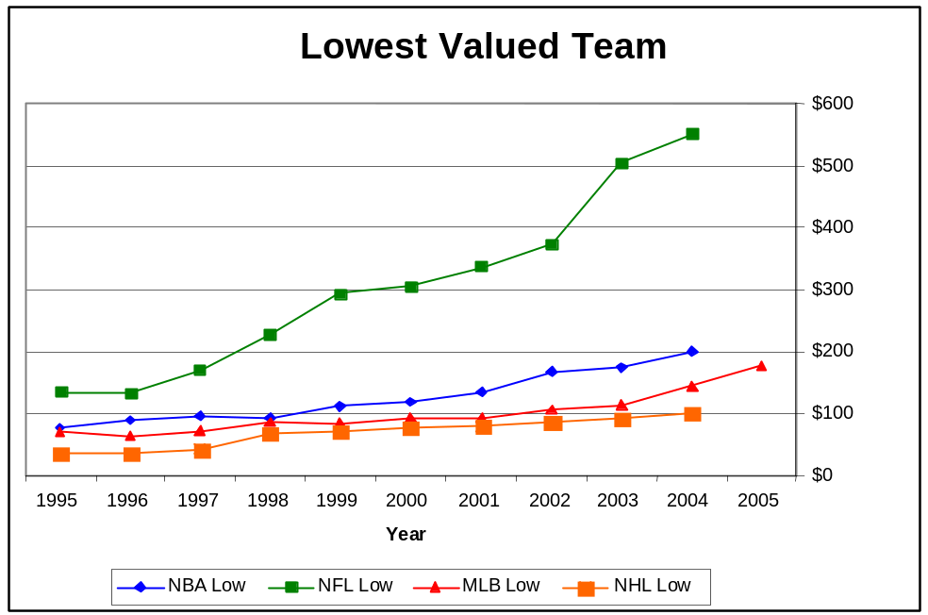

The same disparities are clear when comparing the lowest valued teams in these four leagues, although once again, no league has kept pace with the NFL. Over the decade, the NFL's lowest valued team has gone from a value of $134 million in 1995 (Indianapolis Colts), to $305 million in 2000 (Arizona Cardinals), rising again to $552 million by 2004 (Cardinals). No other league has seen comparable growth in this same ten year span, as is shown below:

MLB= 1995 - $70 M (Pittsburgh Pirates) | 2000 - $92 M (Montreal Expos) | 2004 - $176 M (Tampa Bay Devil Rays

NBA= 1995 - $77 M (Indiana Pacers) | 2000 - $118 M (Vancouver Grizzlies) | 2004 - $199 M (Milwaukee Bucks)

NHL= 1995 - $35 M (Winnipeg Jets) | 2000 - $77 M (Edmonton Oilers) | 2004 - $100 M (Carolina Panthers)

Perhaps these high and low values better explain the disparities among the leagues. The NFL, known as the most successful league, has seen strong growth among teams at the high, average and low ends. Although MLB has kept pace at the high end, primarily due to the increasing value of the New York Yankees, the NBA and NHL have not kept pace, especially at the low end. This is especially striking when looking at the NHL. Although the league's average (from $71 to $163), high ($124 to $282) and low ($35 to $100) team values all increased, no percentage increase was higher than 227%, while in the NFL the overall percentage increase in the lowest team value was 412%.

Beyond these general comparisons, the following provides information specific to each league.

National Football League

The following chart represents the growth in value of the highest and lowest valued teams, along with an average annual value, for teams in the NFL over the past 10 years. The exact team values can be found in the table below the chart.

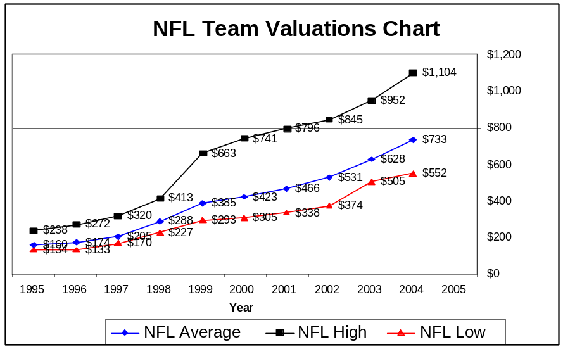

 | 2004 | 2003 | 2002 | 2001 | 2000 | 1999 | 1998 | 1997 | 1996 | 1995
Average | $733 | $628 | $531 | $466 | $423 | $385 | $288 | $205 | $174 | $160
High | $1104 (WAS) | $952 (WAS) | $845 (WAS) | $796 (WAS) | $741 (WAS) | $663 (DAL) | $413 (DAL) | $320 (DAL) | $272 (DAL) | $238 (DAL)
Low | $552 (AZ) | $505 (AZ) | $374 (AZ) | $338 (ATL) | $305 (AZ) | $293 (DET) | $227 (IND) | $170 (IND) | $133 (CAR) | $134 (IND)

- AVERAGE: In 1995, the average value for an NFL team was $160 million. As of 2004, the average value for an NFL team was $733 million, which is an increase of $573 million (458%).

- HIGH: In 1995, the highest valued team, the Dallas Cowboys, was worth $238 million. As of 2004, the NFL’s highest valued team, the Washington Redskins, is worth over $1.104 billion, which is an increase of $866 million (463%).

- LOW: The NFL’s lowest valued team in 1995, the Indianapolis Colts, was worth $134 million. As of 2004, the lowest valued team, the Arizona Cardinals, was worth $552, which is an increase of $418 million (412%).

Although the NFL has seen tremendous growth at each level, the rich have gotten richer as the annual average team value and teams with the highest value have seen the most growth, with the teams with the highest values demonstrating the greatest increase. Regardless of this, overall the NFL has seen over 410% growth at the low, average and high ends.

Major League Baseball

The following chart represents the growth in value of the highest and lowest valued teams, along with an average annual value, for teams in MLB over the past 11 years. The exact team values can be found in the table below the chart.

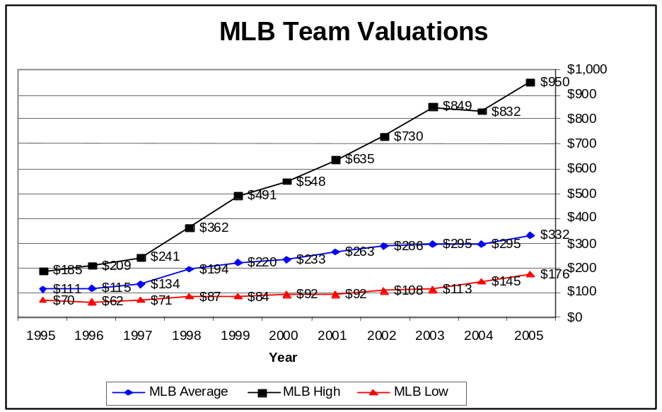

 | 2005 | 2004 | 2003 | 2002 | 2001 | 2000 | 1999 | 1998 | 1997 | 1996 | 1995
Average | $332 | $295 | $295 | $286 | $263 | $233 | $220 | $194 | $134 | $115 | $111
High | $950 (NY) | $832 (NY) | $849 (NY) | $730 (NY) | $635 (NY) | $548 (NY) | $491 (NY) | $362 (NY) | $241 (NY) | $209 (NY) | $185 (NY)
Low | $176 (TB) | $145 (MTL) | $113 (MTL) | $108 (MTL) | $92 (MTL) | $92 (MTL) | $84 (MTL) | $87 (MTL) | $71 (PIT) | $62 (PIT) | $70 (PIT)

- AVERAGE: In 1995, the average value for an MLB team was $111 million. As of 2005, the average value for an MLB team is $332 million, which is an increase of $221 million (299%).

- HIGH: In 1995, the team with the highest value was the New York Yankees franchise worth $185 million. In 2005, the Yankees are still the highest valued team, worth $950 million, which is an increase of $765 million (513%).

- LOW: In 1995, the team with the lowest value was the Pittsburgh Pirates worth $70 million. In 2005, the league’s lowest valued team, the Tampa Bay Devil Rays, is worth $176 million, which is an increase of $106 million (251%).

Although MLB has seen growth at every level, the most growth has been in the team with the highest value, the New York Yankees. Interestingly, the Yankees franchise is also the only team in any league that has remained as the highest valued team over the entire period.

National Basketball Association

The following chart represents the growth in value of the highest and lowest valued teams, along with an average annual value, for teams in the NBA over the past 10 years. The exact team values can be found in the table below the chart.
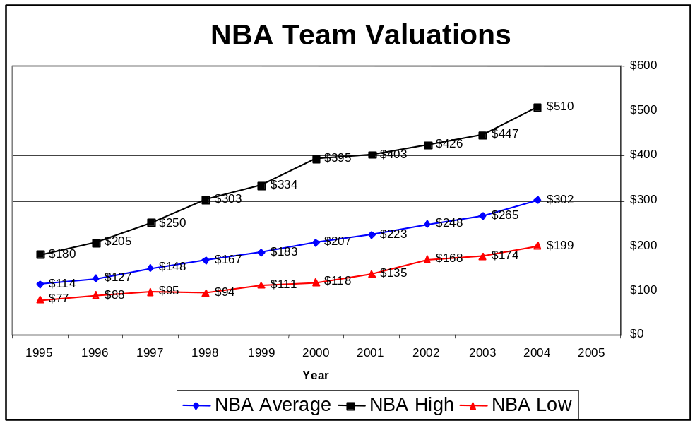

 | 2004 | 2003 | 2002 | 2001 | 2000 | 1999 | 1998 | 1997 | 1996 | 1995
Average | $302 | $265 | $248 | $223 | $207 | $183 | $167 | $148 | $127 | $114
High | $510 (LAL) | $447 (LAL) | $426 (LAL) | $403 (LAL) | $395 (NY) | $334 (NY) | $303 (CHI) | $250 (NY) | $205 (NY) | $180 (DET)
Low | $199 (MIL) | $174 (MIL) | $168 (MIL) | $135 (CHA) | $118 (VAN) | $111 (MIL) | $94 (MIL) | $95 (LAC) | $88 (LAC) | $77 (IND)

- AVERAGE: In 1995, the average value for an NBA team was $114 million. In 2004, the average value for an NBA team is $302 million, which is an increase of $188 million (265%).

- HIGH: In 1995, the team with the highest value as the Detroit Pistons worth $180 million. In 2004, the team with the highest value is the Los Angeles Lakers, worth $510 million, which is an increase of $330 million (283%).

- LOW: In 1995, the team with the lowest value was the Indiana Pacers worth $77 million. In 2004, the team with the lowest value is the Milwaukee Bucks, worth $199 million, which is an increase of $122 million (258% increase).

Overall, similar to the NFL's overall growth, the NBA's growth has been relatively consistent at each level on a percentage basis. However, the NBA's current team values are higher than MLB at the average (NBA = $302, MLB = $295) and low (NBA = $199, MLB = $145) levels, although they are comparable. The NBA's current team values are almost double the NHL's team values at every level (NBA average = $302, NHL average = $163 | NBA high = $510, NHL high = $282 | NBA low = $199, NHL low - $100).

National Hockey League

The following chart represents the growth in value of the highest and lowest valued teams, along with an average annual value, for teams in the NHL over the past 10 years. The exact team values for each figure can be found in the table below the chart.
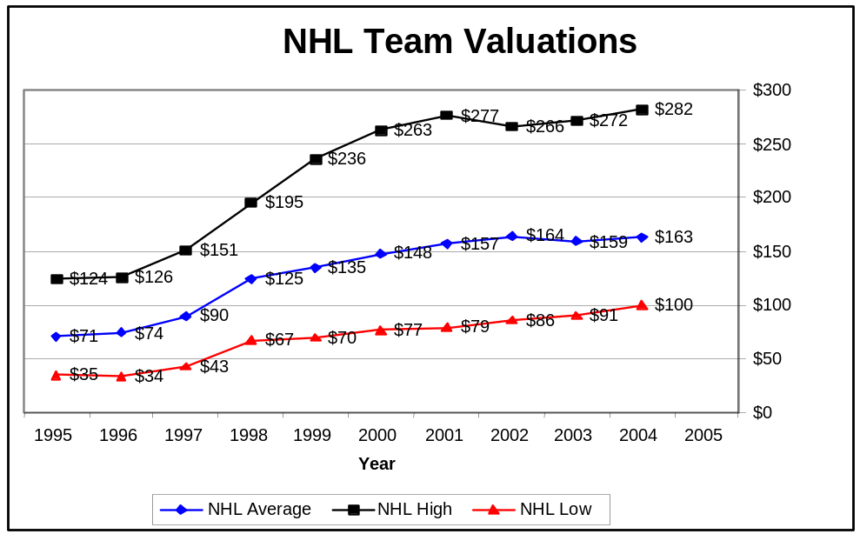

 | 2004 | 2003 | 2002 | 2001 | 2000 | 1999 | 1998 | 1997 | 1996 | 1995
Average | $163 | $159 | $164 | $157 | $148 | $135 | $125 | $90 | $74 | $71
High | $282 (NYR) | $272 (NYR) | $266 (DET) | $277 (NYR) | $263 (NYR) | $236 (NYR) | $195 (NYR) | $151 (CHI) | $126 (DET) | $124 (DET)
Low | $100 (CAR) | $91 (EDM) | $86 (EDM) | $79 (PHX) | $77 (EDM) | $70 (CAR) | $67 (EDM) | $43 (PHX) | $34 (WIN) | $35 (WIN)

- AVERAGE: In 1995, the average value for an NHL team was $71 million. In 2004, the average value for an NHL team is $163 million, which is an increase of $92 million (230%).

- HIGH: In 1995, the team with the highest value was the Detroit Red Wings worth $124 million. In 2004, the team with the highest value is the New York Rangers worth $282 million, which is an increase of $158 million (227%).

- LOW: In 1995, the team with the lowest value was the Winnipeg Jets worth $35 million. In 2004, the team with the lowest value is the Carolina Hurricanes worth $100 million, which is an increase of $65 million (285%).

Although the NHL has seen the least growth in team values over the past decade, its' percentage growth in team value at every level is comparable to the NBA's, and is comparable to MLB's at every level except for the value of the highest-level teams. Still, the NHL's highest growth, $158 million or 227% for its highest valued team, is still only at a team value of $282 million. As of 2004, this is still $228 million less than the NBA, and a staggering $668 million less than MLB, and $822 million less than the NFL.

